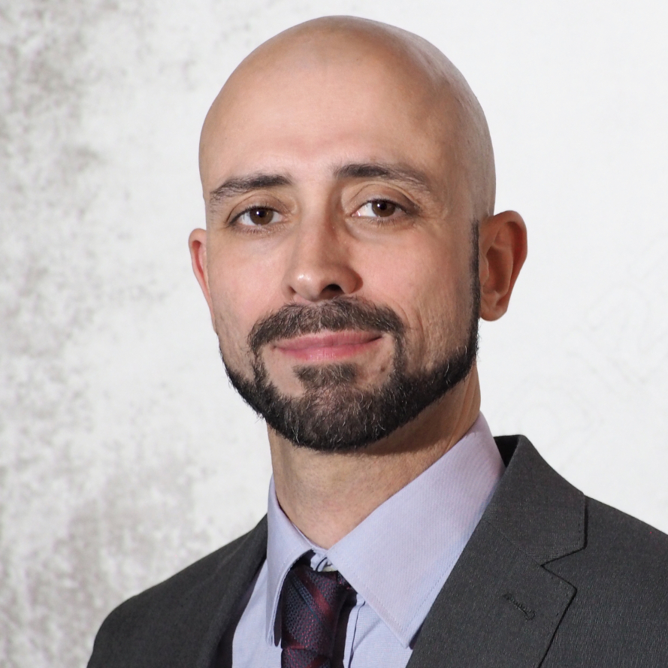
Juan Hernández
Electronics Development Engineer
Berlin, Germany
Tel.: 01575 96 353 96
Web: http://www.juanhernandezhernandez.com/en
E-Mail: contact@juanhernandezhernandez.com

Curriculum Vitae
Personal Information

Year of birth: | 1978
Nationality: | Spanish
Marital status: | Married

Work Experience And Fields Of Competence

Electronic Sector
4/2014-present | EBK Krüger GmbH, Teltow, Berlin (Germany) - Research & Development Bachelor Engineer
- Software development (NI LabVIEW): machine vision in two production lines, test benches for specific tests
- Product development (BVG, Bosch, Porsche, Daimler): feasibility analysis and cost calculation, specification setting (along with customer), hardware conception and development, software design and programming (PIC microcontrollers), development from test benches (Hardware and software), support to the Quality department, testing, commissioning and delivery to the client, writing of technical documentation
- Prototypes development and building, PCB layouts design with Altium Designer
- Programming of Programmable Logic Controllers (PLCs): Siemens Simatic S7-1200, Bosch CL200, Siemens LOGO!, work with ASi-Bus and ProfiBus
- Other software: Microchip MPLAB X IDE, Siemens TIA Portal, MS Dynamics NAV
- Participation in FMEA meetings and elaboration of 8D reports
3/2010-7/2013 | TEMAI Ingenieros, Getafe, Madrid (Spain) - Research & Development Bachelor Engineer
- Work in test laboratories in aeronautic field. NATO Restricted security clearance
- Execution of different kind of tests, based on various standard norms, carried out on electromechanic actuators and electronic controllers
- Responsible of the migration of the Control and Instrumentation of a test bench based on NI FieldPoint to a Real-Time system (NI LabVIEW + NI cRIO)
- Development of automatic software (NI LabVIEW): Test Automation, analysis and publication of test results, calibration of measurement chains
- Improvements identification and implementation, tracking of new opportunities
- Writing, publication and distribution of documentation and technical reports
- Diverse projects: programming of test benches (NI LabVIEW and C/C++), protocols (CANBus, ARINC429, Ethernet, RS232), artificial vision, hardware/software integration, analysis of offers
11/2008-3/2009 | Avistel S.A.R.L., Carrières-sur-Seine (France) - Senior Electronic Technician
- Programming and tuning up of embedded software on the new components
- Detection of failures in embedded electronic, quality management of products and services
7/2007-10/2007 | Etralux S.A., Madrid (Spain) - Senior Electronic Technician
- Installation, starting-up and testing of electronic systems of information and communication
- Management of payment systems and of vehicles power circuits

6/2004-9/2004 | Trelleborg Automotive UK, Trowbridge (United Kindom) - Senior Electronic Technician
- Programmable Logic Controllers programming (OMRON, Siemens) and CNC programming
- Installation and connection of equipment using industrial field buses (Profibus, CAN)
Experience in other fields: metallurgic sector (2001-2007), transports and logistic

Studies

9/2005-9/2008 | Bachelor’s Degree in Industrial Electronics, Escuela Universitaria, Valladolid (Spain). Award with Special Distinction
 | Final Degree Project “Establishment of a RANSAC Algorithm for Pictures Segmentation”, Escuela Universitaria Politécnica, Valladolid (Spain). Passed with Distinction
9/2003-6/2005 | Higher Technical Certificate in Electronic Products Development, Instituto de Enseñanza Secundaria (High School) La Merced, Valladolid (Spain)

Training And Certificates

4/2015 | „Altium Designer - Vault Training”, Altium Certification and Training
2/2015 | „Failure Mode and Effects Analysis (FMEA)”, VDA QMC
12/2014 | „Live-line Working”, BG ETEM
9/2014 | „High Frequency Basics”, Würth Elektroniks
8/2014 | „HF Devices - Impedance Control on printed circuit boards (PCBs)”, FED Berlin
4/2012 | “LabVIEW Realtime and Simulation Interface Toolkit”, National Instruments
2/2012 | “Dynamic Systems Simulation Using Matlab And Simulink”, TEMAI Ingenieros
3/2008 | Certificate “Assessment Of The Impact Upon The Environment”, Universidad De Valladolid
4/2005-6/2005 | Training In Electronic Products Development, Sifisa, S.L., Valladolid (Spain)

Other Skills

Languages | German: C1
 | English: advanced level (“First Certificate in English”)
 | French: advanced level (Certificate “DELF B2”)
 | Spanish: mother-tongue
It Skills | Technical Software: NI LabView (Real-Time, FPGA, MathScript, Vision and Motion, Database Connectivity modules), Altium Designer, MatLab, OrCad, microcontrollers (MPLAB X IDE) and PLD programming, programmable logic controllers programming (TIA Portal, WinSPS, WinDP)
 | Programming Languages: C/C++, Visual Basic, NI DIAdem Script, Assembler, VHDL, HTML, CSS
 | Office Software (Microsoft Office and Dynamics NAV)
Driving License | B

Personal Interests

Hobbies: | Travelling and meeting people, sport climbing and bouldering, guitar playing, music

